

Subject Name: **Source Code Management**

Subject Code: **24CSE0106** Session: **2024-25** Department: **CSE**

**logo**

|  |  |
| --- | --- |
| **Submitted By:**  Harshit Hassija 2410990333  G5 | **Submitted To:**  Dr. Chetna Sharma |

# List of Programs

|  |  |  |
| --- | --- | --- |
| **S. No** | **Program Title** | **Page No.** |
| 1 | To install and configure Git Client on your local system | 3 - 5 |
| 2 | Setting up GitHub account and adding collaborators on GitHub Repository | 6 – 8 |
| 3 | To merge two branches with a Git repository | 9 - 10 |
| 4 | To demonstrate push and pull operations in Git | 11 |

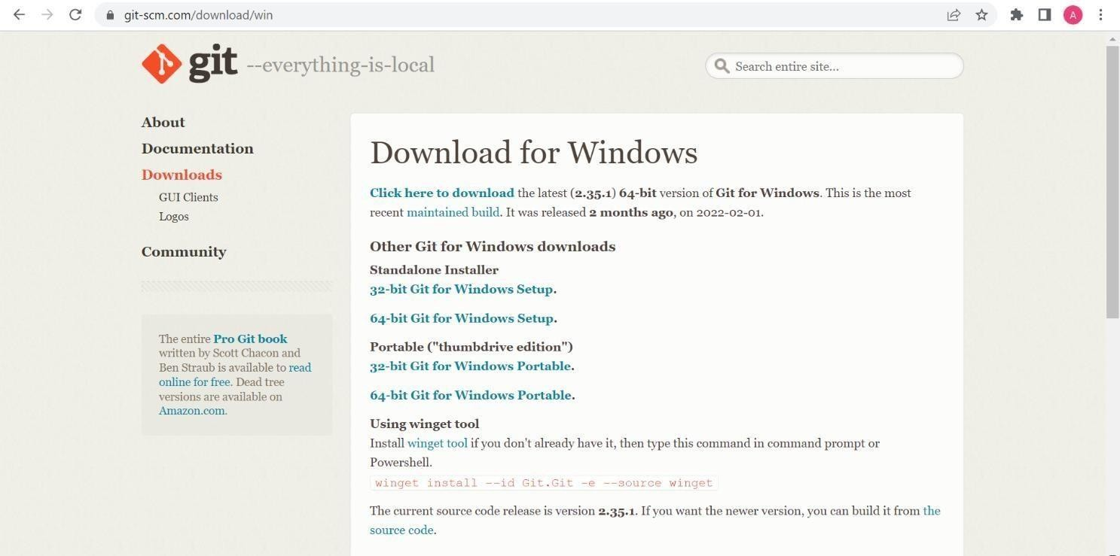

## Experiment 1

**Aim:** To install and configure Git Client on your local system.

## Theory:

Git is a distributed version control system used to track changes in source code. This practical focuses on setting up Git on your local system for effective version control.

## Procedure:

* Download Git from git-scm.com.
* Install Git by following the setup wizard.
* Open Git Bash and verify installation using the command: git --version.
* Configure user details using the commands:

git config --global user.name "Your Name" git config --global user.email "Your Email"

## Snapshots of download:

Opted for “64-bit Git for Windows Setup”

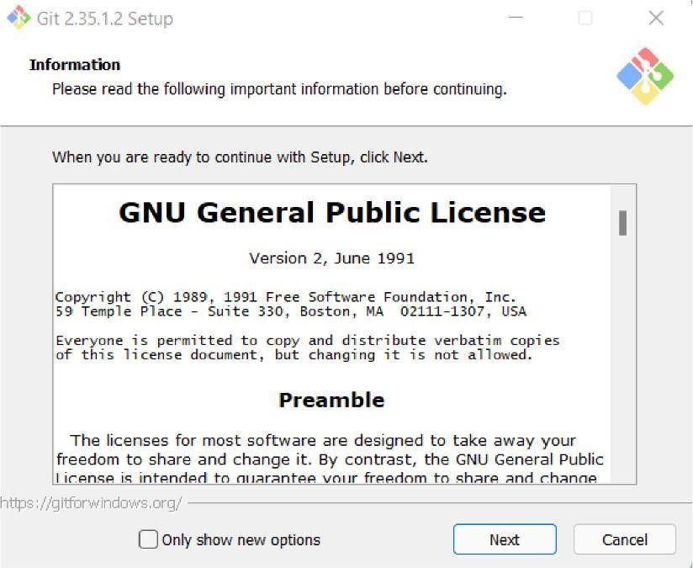

Git Setup

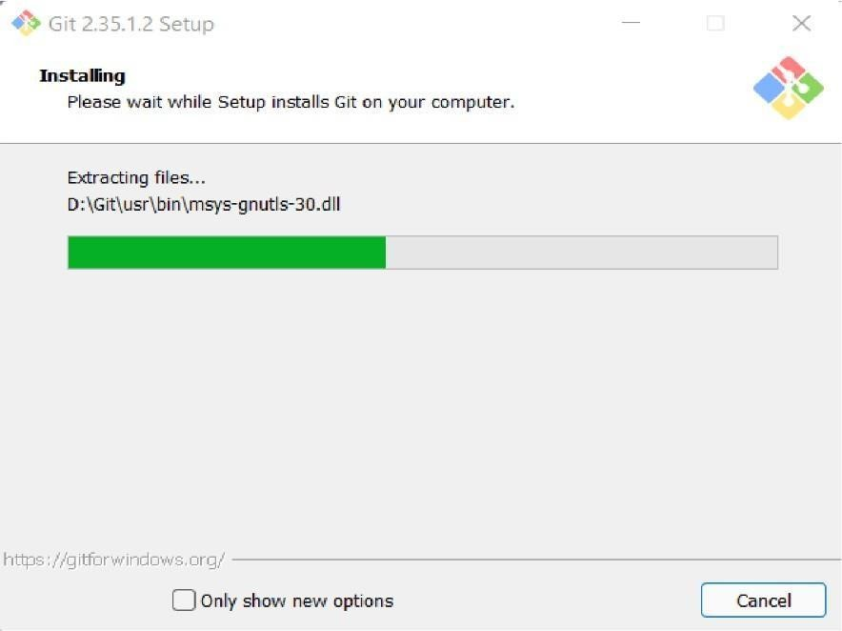

Git Installation

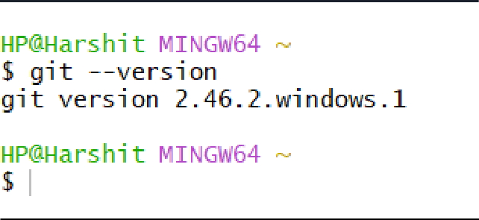

Git Bash version

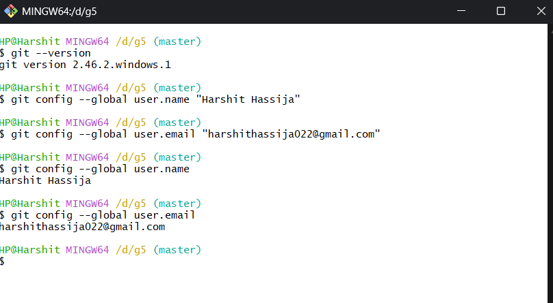

## Practical 2

**Aim:** Setting up GitHub Account and Adding Collaborators on GitHub Repository

## Theory:

Collaborators are individuals with write access to a repository. They can contribute to the project by pushing changes and merging pull requests.

## Procedure:

* Log in to your GitHub account and create a new repository.
* Navigate to Settings > Manage Access in the repository.
* Add collaborators by their GitHub usernames.
* Collaborators will receive an invitation email, which they must accept.

# Snapshots :

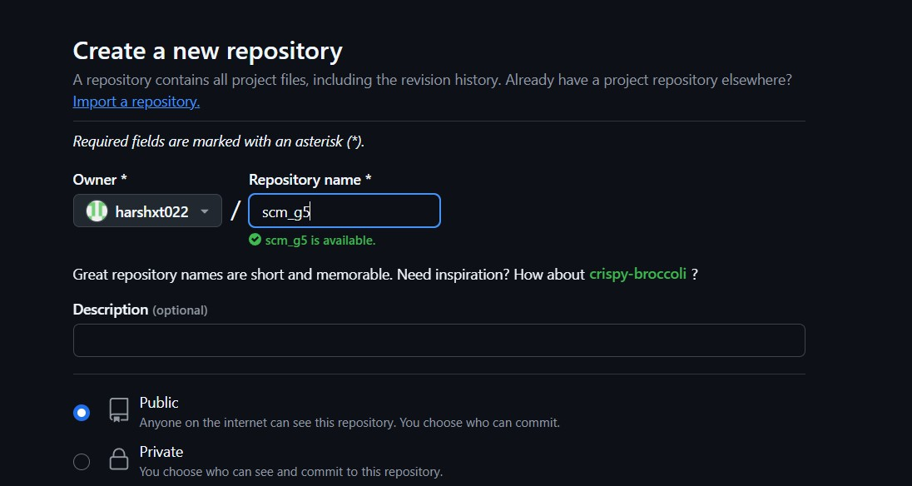

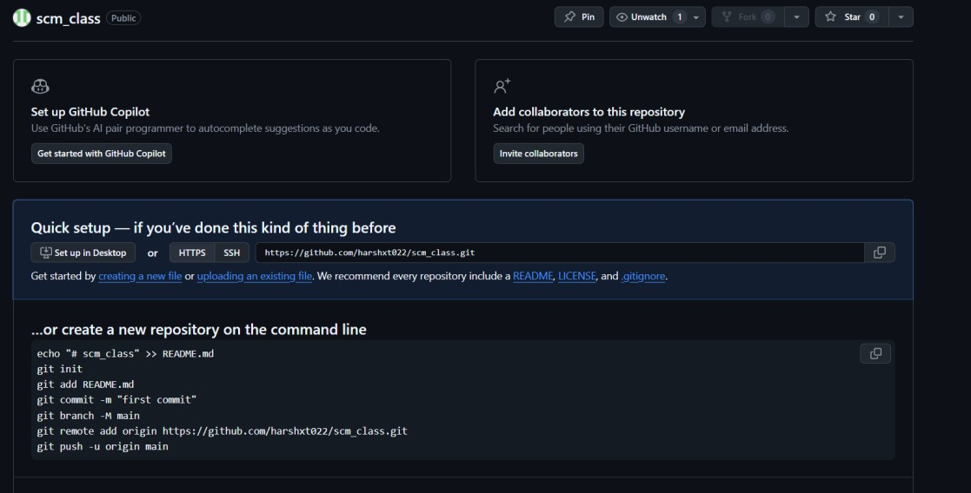

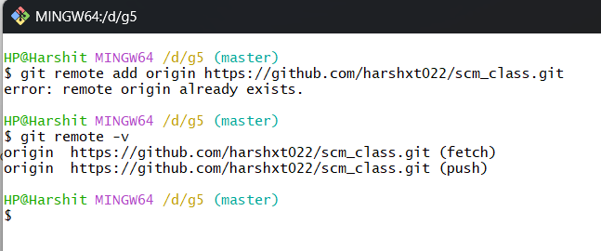

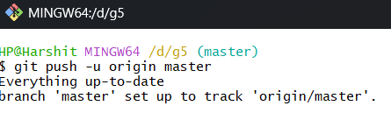

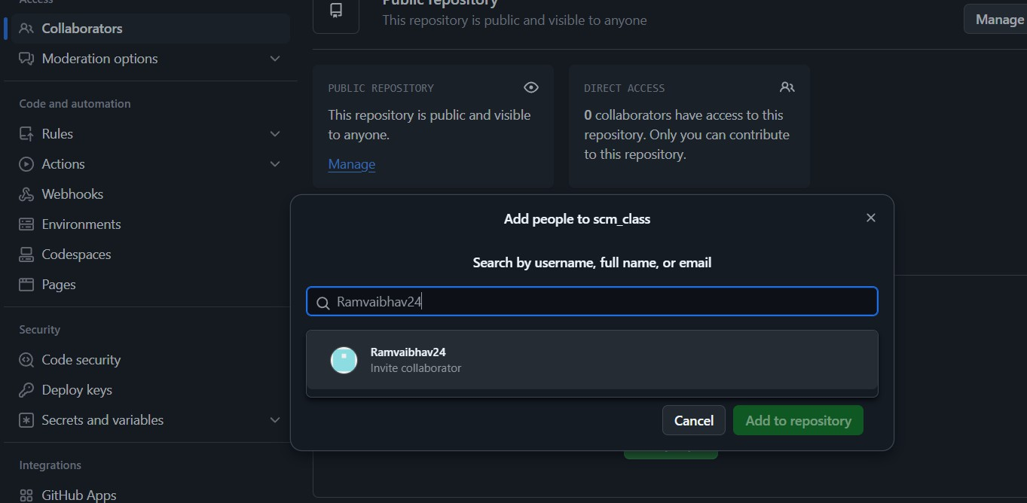

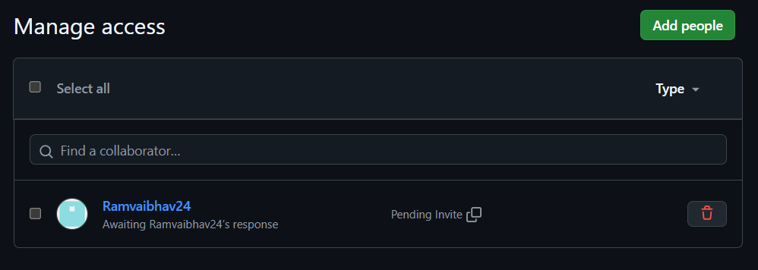

## Practical 3

**Aim:**

To merge two branches within a Git repository**.**

## Theory:

Merging branches in Git allows you to combine changes from one branch into another. It is a fundamental process in collaborative workflows, ensuring all contributions are integrated into a single codebase.

## Procedure:

1. Create a new branch and switch to it:

git checkout -b new-branch

1. Make changes to a file in the new branch and commit them: echo "New content" > file.txt

git add file.txt

git commit -m "Add changes in new branch"

1. Switch back to the main branch:

git checkout main

1. Modify another file in the main branch and commit the changes: echo "Main branch changes" > another-file.txt

git add another-file.txt

git commit -m "Modify file in main branch"

1. Merge the new branch into the main branch:

Git merge new-branch git merge new-branch **Snapshots:**

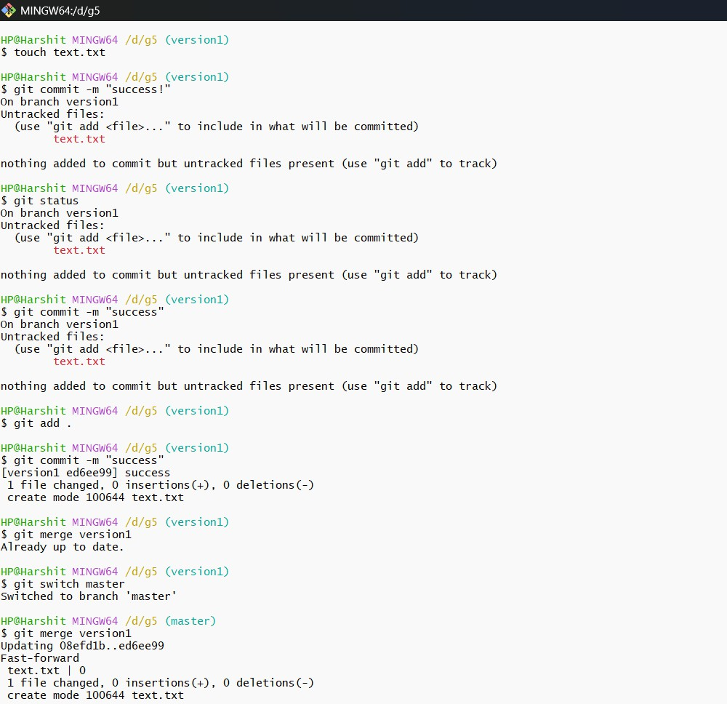

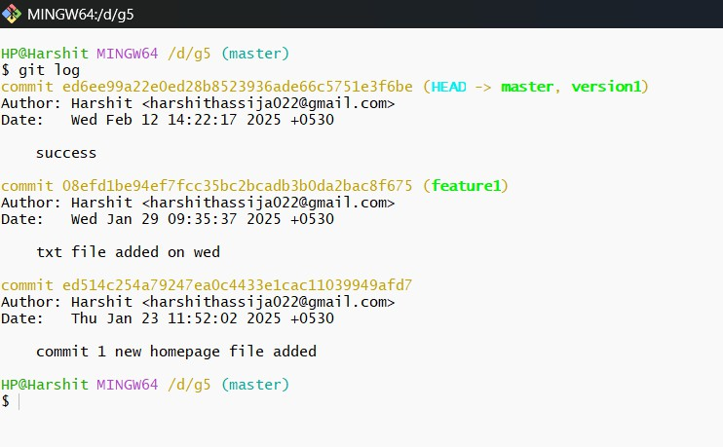

## Practical 4 Aim:

To demonstrate push and pull operations in Git.

## Theory:

Push transfers committed changes from the local repository to the remote repository, while pull retrieves updates from the remote repository.

## Procedure:

* Make changes in the local repository and commit them.
* Push the changes to the remote repository using git push.
* Make changes directly on the remote repository (e.g., via GitHub interface).
* Pull the changes to the local repository using git pull.

## Tasks:

Provide screenshots of the push and pull operations. Include the updated commit log.

**Screenshots**

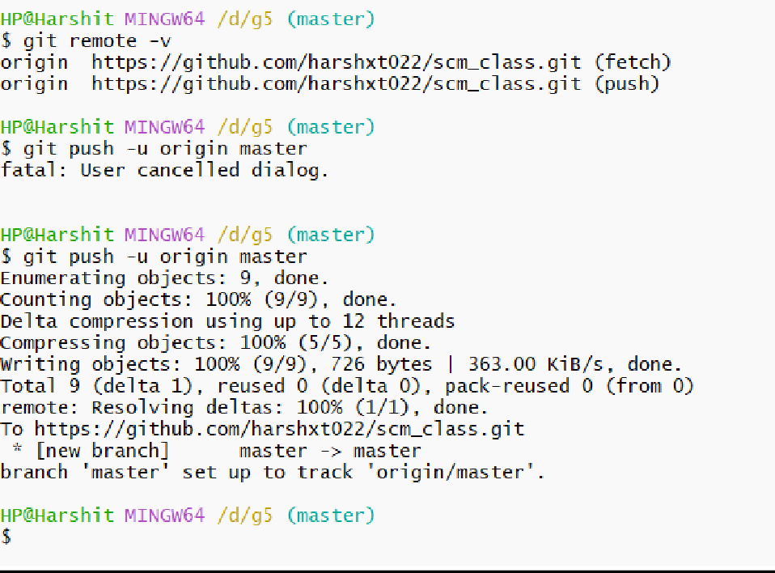

**Practical 5**: Clone, Fork, and Create Pull Requests

**Aim:** To demonstrate the concepts of forking, cloning, and creating pull requests on GitHub.

**Theory**: Forking creates a personal copy of a repository, cloning downloads it locally, and pull

requests propose changes to the original repository.

**Procedure:**

1. Fork an existing repository on GitHub.

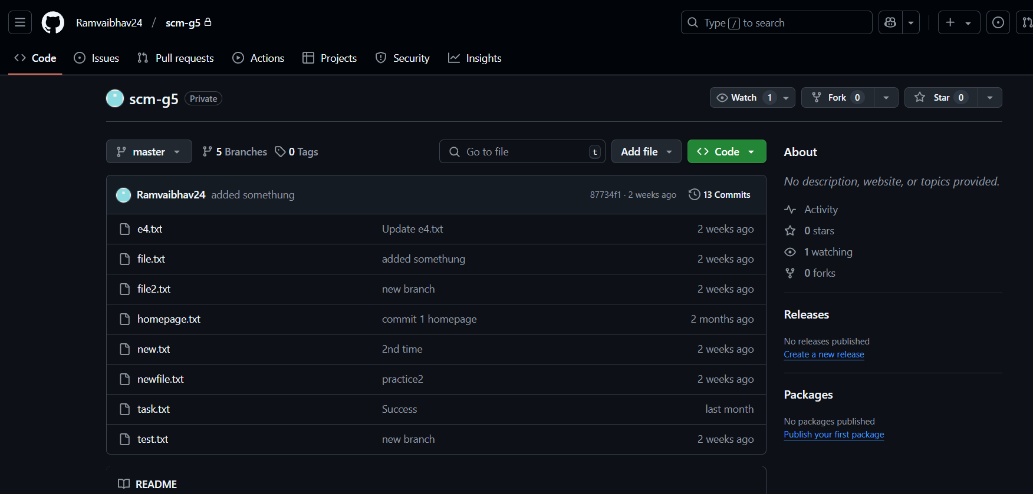

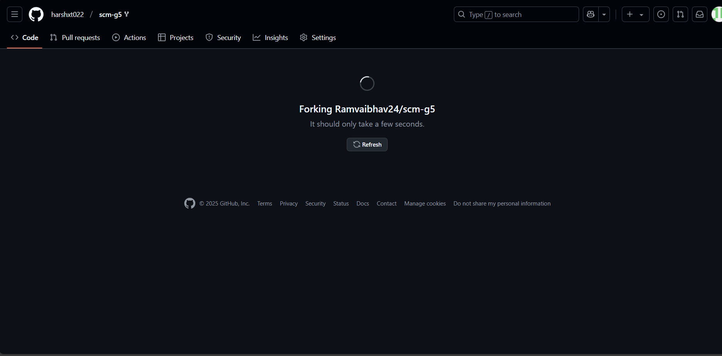

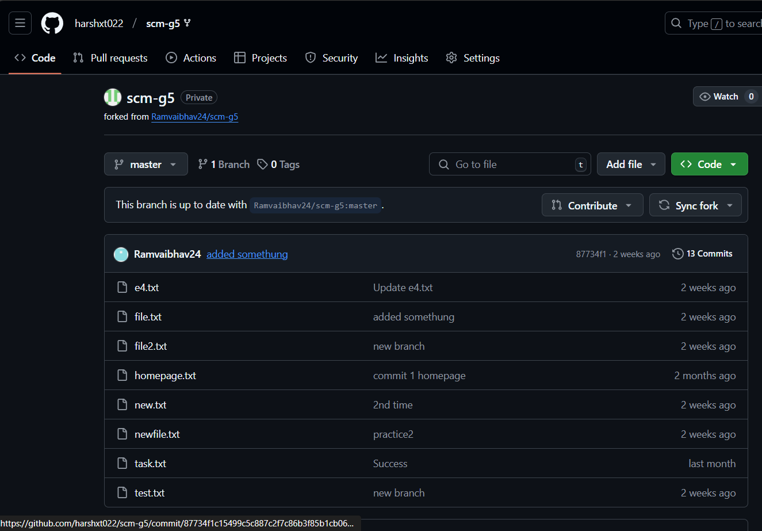

1. Clone the forked repository using git clone <URL>.

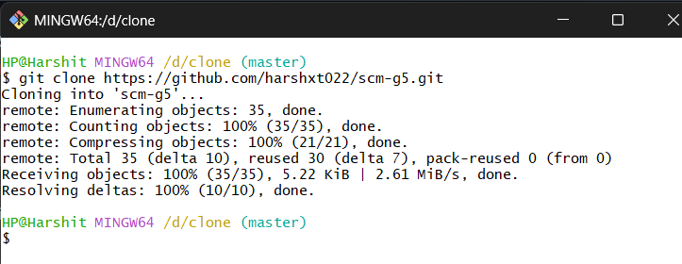

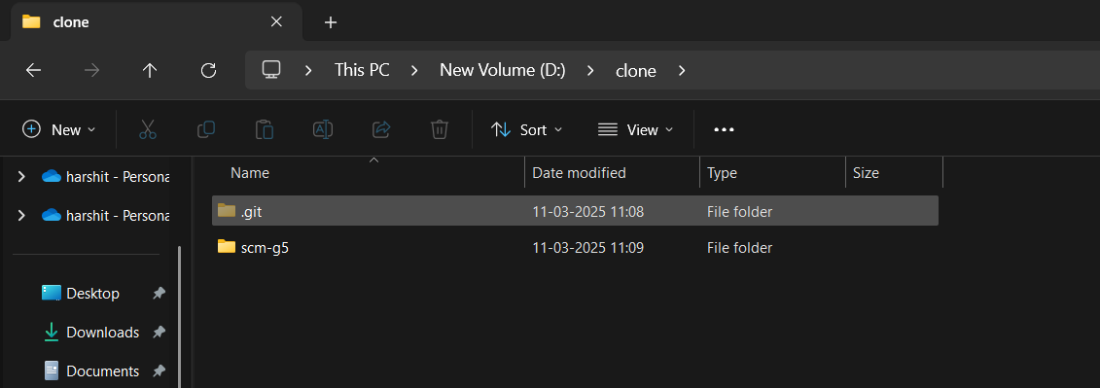

Repository cloned

1. Make changes in the cloned repository and push them to your forked repository.

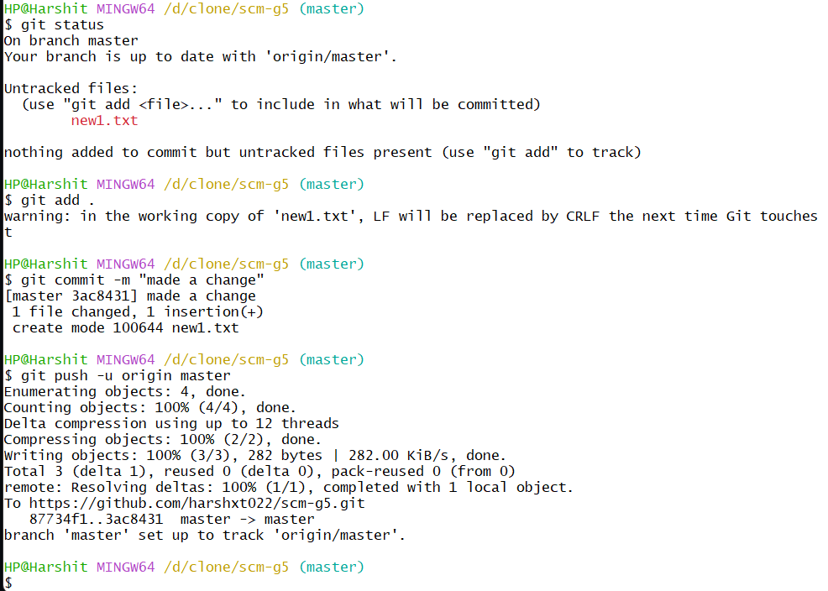

1. Create a pull request to propose changes to the original repository.

